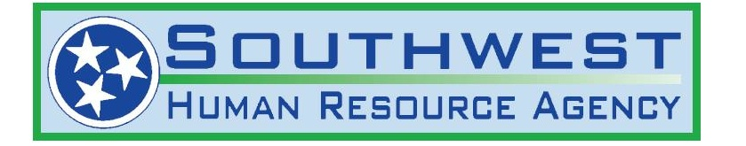

FREE MEALS FOR CHILDREN
18 AND UNDER

Southwest HRA will be providing meals to the children of Hardin County as of 6/1/2021.

Our agency will be distributing a lunch and a breakfast that will be for the following day.

We will be at the following locations and times each day, Monday-Friday.

Hardin County
1 Stadium Drive 10:45 – 11:30
Savannah, Tn.

Children 18 and under are eligible to receive meals.

We ask that parents remain in their cars and we will bring meal packets to the car.

Southwest HRA is also asking for assistance from volunteers who may want to provide their time to hand out these meals or direct traffic. Please contact Patti or Norma at 1-800-497-1286 for more information.

